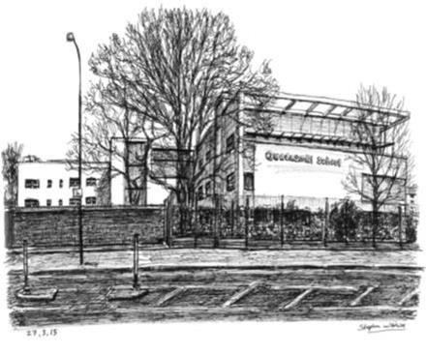

Project SEARCH Intern Application Form
West Middlesex University Hospital
2020/2021

Please return completed application forms by Friday 31st January 2020 to:

projectsearch@queensmill.lbhf.sch.uk

or

Neeta Singh
Queensmill College
1 Askham Road
London
W12 0NW

Project SEARCH Intern Application
West Middlesex University Hospital
2020 – 2021

Please complete this application form for consideration to be part of the Project SEARCH course 2020/2021 and return it to Neeta Singh by email or post by Friday 31st January 2020. The information can be completed on behalf of the intern.

Prospective Intern Information

Name
Address
Date of Birth
Contact Number
Email Address
National Insurance Number

Parent/Guardian/Carer Information

Name
Address
Contact Number
Email Address

Application Questions

Do you have an EHC plan? |  | Yes |  |  | No
Do you want a job? |  | Yes |  |  | No
Are you between the ages of 17 and 25? |  | Yes |  |  | No
Can you travel independently? |  | Yes |  |  | No
How do you plan to travel to Project SEARCH? |  | Walk | Bus | Train | Taxi | Parents |  | Other
Please disclose any health or medical conditions that we need to be aware of, or that may impact upon an internship rotation or employment:
What do you think you will enjoy most about working?
What areas do you think you will need support with? (Please tick the appropriate answers) | Timekeeping
 | Working with others
 | Communicating with others
 | Working independently
 | Following instructions
 | Completing tasks you do not enjoy
 | Meeting new people/environments
 | Keeping a positive attitude
 | Other:
What are your interests and hobbies?

Previous Work Experience - What previous work experience have you completed?

Company Name | Job Title | Responsibilities | Dates

I certify that my answers are true and complete to the best of my knowledge.
Signature |  | Date
Reference – Please ask your teacher or key worker to complete this section

Reference in support of:
Please give details regarding the applicant’s suitability for Project SEARCH. Include information about their desire to work and learn new skills, personal and social skills, ICT skills, attendance record, and any other relevant information

___________________________________________________________________________________________________________________________________________________________________________________________________________________________________________________________________________________________________________________________________________________________________________________________________________________________________________________________________________________________________________________________________________________________________________________________________________________________________________________________________________________________________________________________________________________________________________________________________________________________________________________________________________________________________________________________________________________________________________________________________________________________________________________________________________________________________________________________________________________________________________________________________________________________________________________________________________________________________________________________________________________________________________________________________________________________________________________________________________________________________________________________________________________________________________________________________________________________________________________________________________________________________________________________________________________________________________________________________________________________________________________________________________________________________________________________________________________________________________________________________________________________________________________________________________
Please sign below to indicate your support for the applicant
Signature |  | Date

